BARTON CREEK RESERVE HOMEOWNER’S ASSOCIATION

AGENDA ITEM REPORT
for the 6/25/2026
EXECUTIVE BOARD MEETING

DATE: June 25, 2026

TO: Barton Creek Reserve (“BCR”)
Homeowner’s Association (“HOA”)
Executive Board (“Board of Directors”)

FROM: Andy Dempsey, BCR HOA Vice President

RE: Barton Ridge Drive Road Repair Contract

BACKGROUND

Section 8.06 of the Declaration of Covenants, Conditions and Restrictions requires the Association to provide regular year round road maintenance services to include pot hole patching. In 2025 an inspection of Barton Ridge Drive revealed several areas of severely cracked pavement. The Associations Vice President solicited bids from local contractors to perform the repairs in fall 2025 but received no bids. In spring 2026 the Association Vice President again solicited bids from contractors for the road repairs. This year he solicited bids from 5 contractors but received only 2 bids in response. The proposed Association Annual Budget includes sufficient funds for these repairs provided that the Owners approve the proposed budget.

DISCUSSION

The two contractors submitting bids were Edwards Asphalt Paving and Summit Contracting. The scope of work for which the Association requested bids was to sawcut and remove the damaged asphalt in 3 locations, one of which was 200 feet long, and repair the road base prior to repaving and sealing the sawcut edge with liquid asphalt.

Edwards Asphalt paving provided a bid an and alternate for crack sealing and sealcoating the entire Barton Ridge Drive. The bid and alternate are shown on the following page.

There are logistical challenges with the alternate proposal submitted by Edwards Asphalt Paving. If we chose to pursue a crack seal and sealcoat alternate, no one would be able to drive on Barton Ridge Drive for 24 hours after it was seal coated. Or, if we did half of the road on one day and half on another, we would have a one lane road that would require traffic control for 24 hours and driveways on one half of the road would be inaccessible for a day. This does not seem to be feasible. The sawcut and patch original scope only requires minor traffic control for a short period of time.

Edwards Asphalt Paving bid for the original scope of work was $7,750.00.

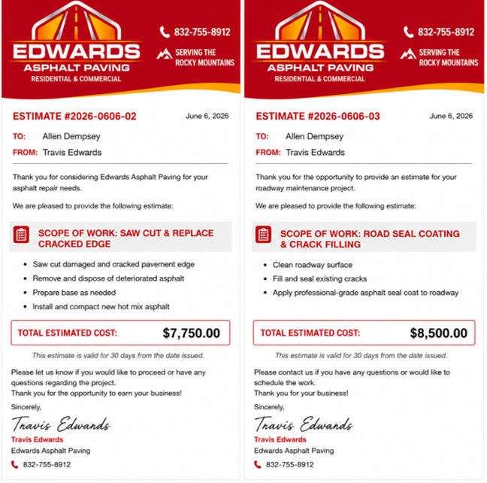

Summit Contracting submitted a bid for the requested scope of work only. Summit Contracting’s bid totaled $14,206.00, which was not surprising since Summit Contracting is a Commerce City based construction company.

Summit Contracting’s line item bid is on the following page.
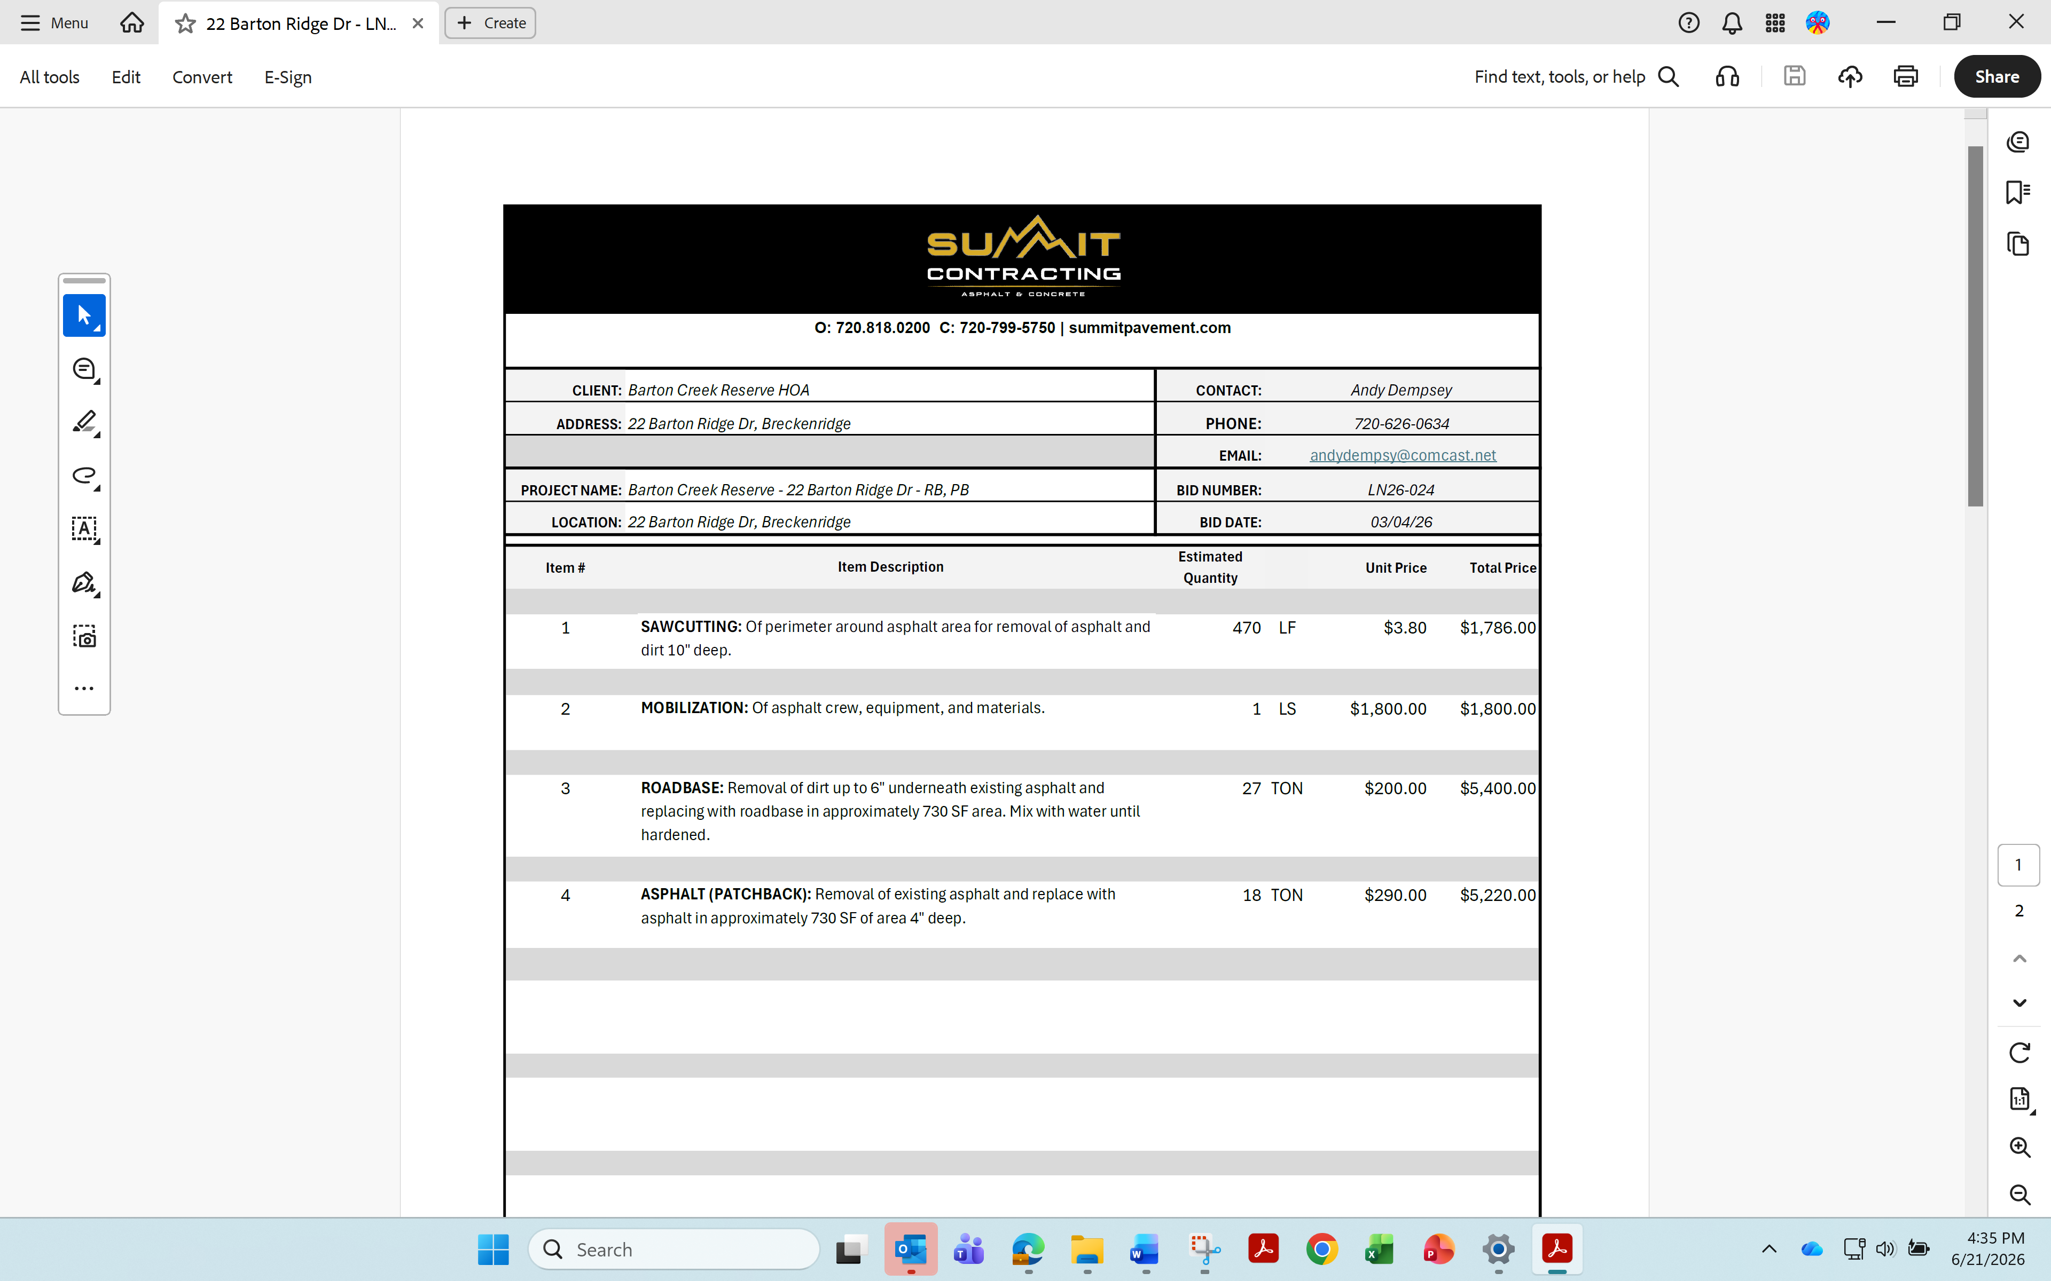

MANAGEMENT RECOMMENDATION

The Association Vice President recommends the Board of Directors vote to accept the Edwards Asphalt Paving bid for $7,750.00 for the original sawcut and replace scope of work.

JUSTIFICATION FOR BOARD ACTION

Article 6 of the Bylaws of Barton Creek Reserve Homeowners’ Association establishes the offices of the Board of Directors and requires the Board of Directors to elect the officers annually.

FINANCIAL IMPACTS

The cost of the work would be $7,750.00. If the proposed budget has been ratified by the Owners, this work is slightly less than budgeted.

PROPOSED MOTION

____________ moves to accept the Edwards Asphalt Paving $7,750.00 bid for Barton Ridge Drive Road Repairs and direct the President to enter into a contract with Edwards Asphalt Paving for the work to be done. ___________ seconds the motion.

Bart Margheim votes _________
Jason Laabs votes __________
Andrew Dempsey votes _______

